Test Case: tc001_SPX_Dev5_Crear_Requisicion_Spot_Tipo_Cobro_CC
Step 1 - Enter username and password and click to button Enter : Credentials Entered
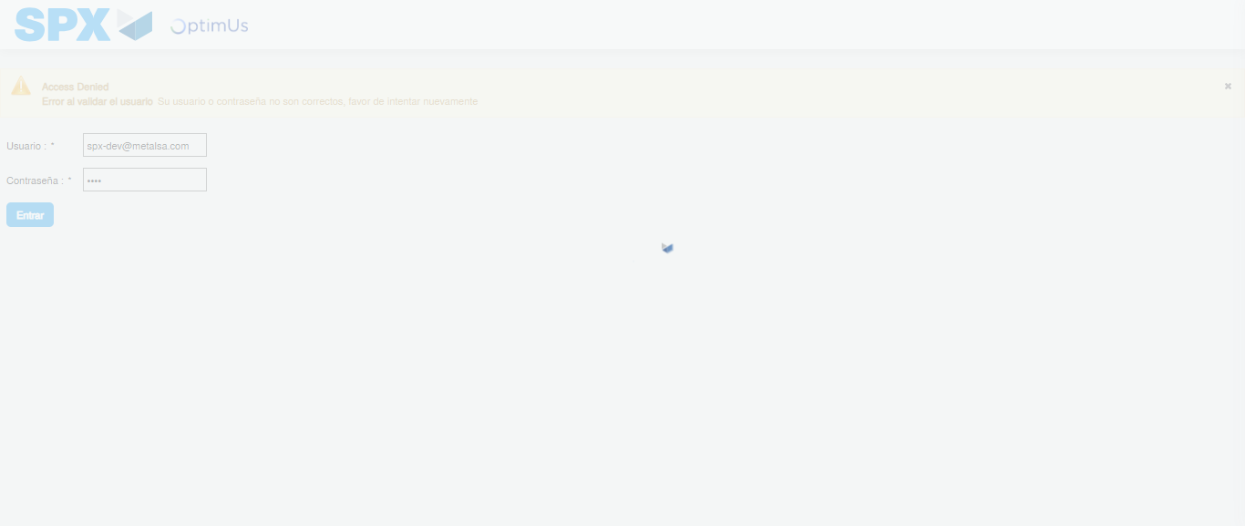Image file-name: QC_Testing-tc001_SPX_Dev5_Crear_Requisicion_Spot_Tipo_Cobro_CC-1783983538101

Step 2 - Select to UEN and Access to Spot Buy Requisitions : UEN Correctly selected and Correct access
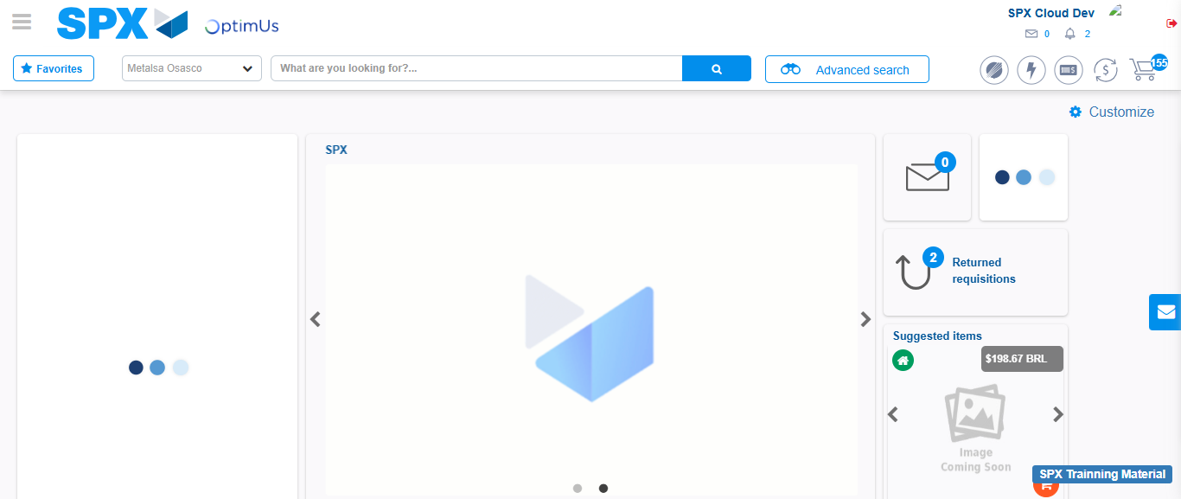Image file-name: QC_Testing-tc001_SPX_Dev5_Crear_Requisicion_Spot_Tipo_Cobro_CC-1783983564399

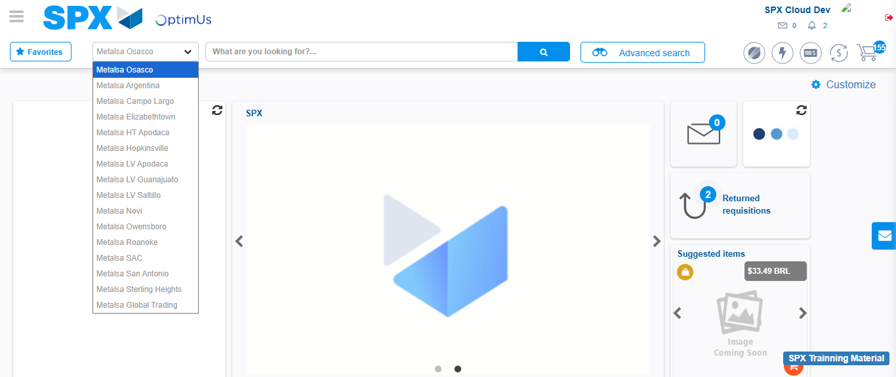Image file-name: QC_Testing-tc001_SPX_Dev5_Crear_Requisicion_Spot_Tipo_Cobro_CC-1783983567090

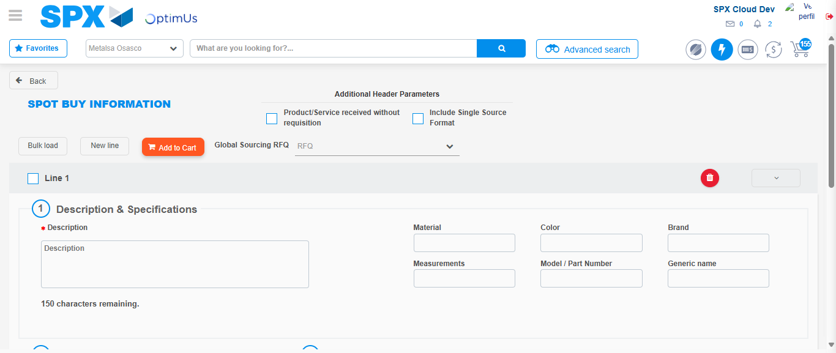Image file-name: QC_Testing-tc001_SPX_Dev5_Crear_Requisicion_Spot_Tipo_Cobro_CC-1783983587390

Step 3 - Data Capture Spot Buy Requisition : Data captured correctly
Image file-name: QC_Testing-tc001_SPX_Dev5_Crear_Requisicion_Spot_Tipo_Cobro_CC-1783983587635

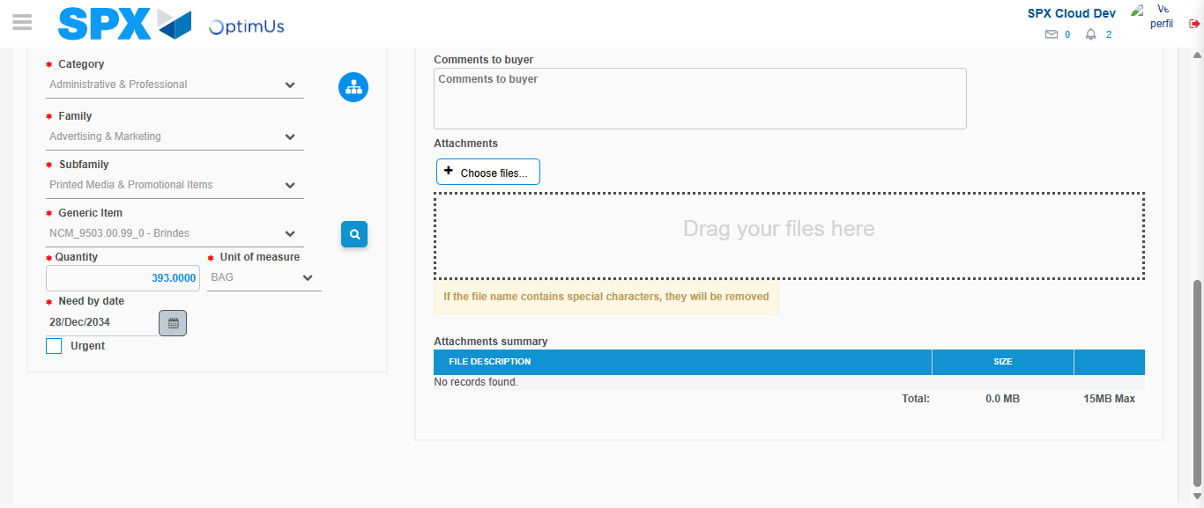Image file-name: QC_Testing-tc001_SPX_Dev5_Crear_Requisicion_Spot_Tipo_Cobro_CC-1783983600341

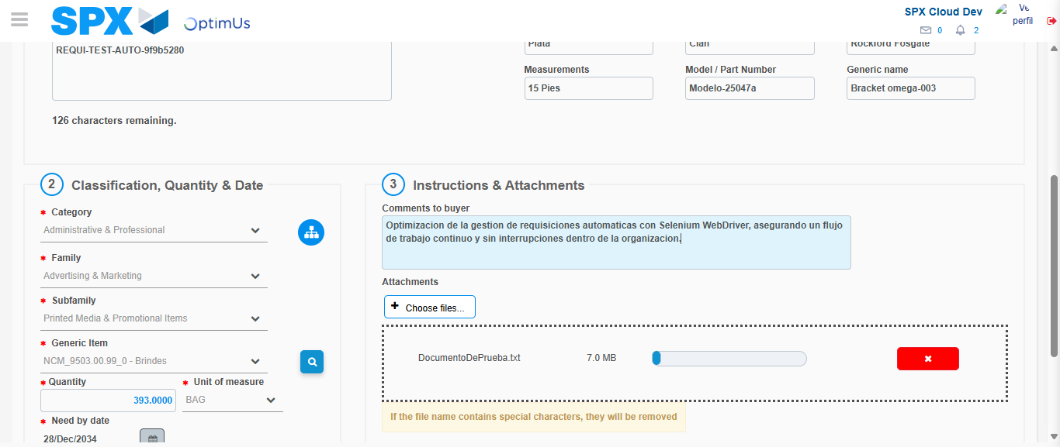Image file-name: QC_Testing-tc001_SPX_Dev5_Crear_Requisicion_Spot_Tipo_Cobro_CC-1783983601120

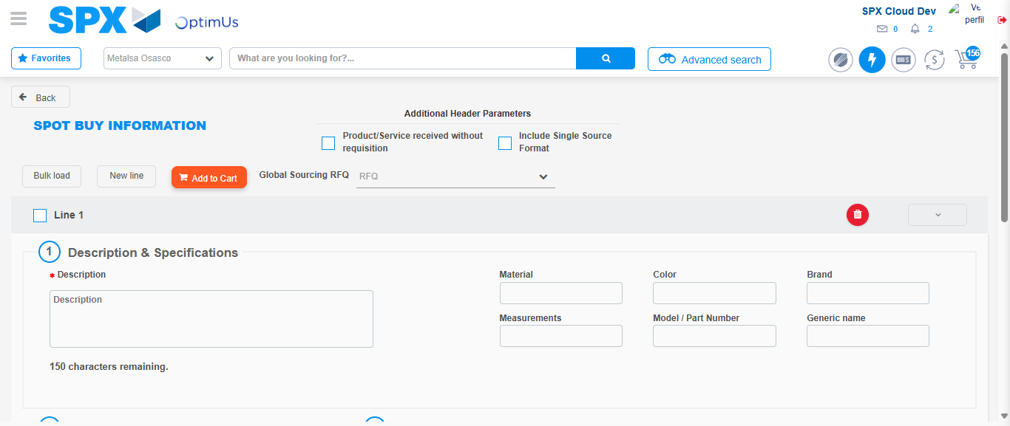Image file-name: QC_Testing-tc001_SPX_Dev5_Crear_Requisicion_Spot_Tipo_Cobro_CC-1783983607684

Step 7 - Return to Main Page SPX : Return to Main Page SPX
Image file-name: QC_Testing-tc001_SPX_Dev5_Crear_Requisicion_Spot_Tipo_Cobro_CC-1783983564399

Image file-name: QC_Testing-tc001_SPX_Dev5_Crear_Requisicion_Spot_Tipo_Cobro_CC-1783983567090

Image file-name: QC_Testing-tc001_SPX_Dev5_Crear_Requisicion_Spot_Tipo_Cobro_CC-1783983587390

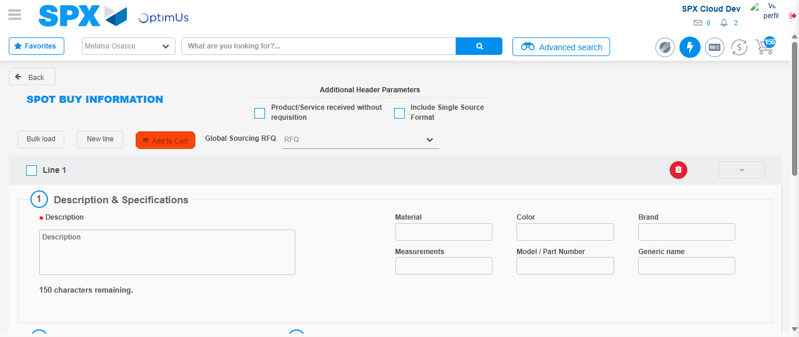Image file-name: QC_Testing-tc001_SPX_Dev5_Crear_Requisicion_Spot_Tipo_Cobro_CC-1783983609948

Image file-name: QC_Testing-tc001_SPX_Dev5_Crear_Requisicion_Spot_Tipo_Cobro_CC-1783983610139

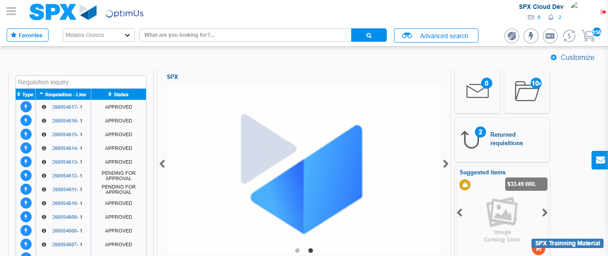Image file-name: QC_Testing-tc001_SPX_Dev5_Crear_Requisicion_Spot_Tipo_Cobro_CC-1783983631213

Step 8 - Log Out : Log Out SPX
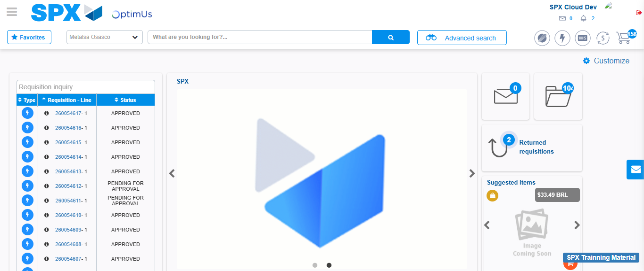Image file-name: QC_Testing-tc001_SPX_Dev5_Crear_Requisicion_Spot_Tipo_Cobro_CC-1783983631470

